 | A15 / AVN
 |  | NMM Socket Task
Abstract
General StepUp Document Template used to create new documents and define other document templates.

Document ID
Author |  |  | Document version | Status | Last update
Narenda Allam – Research Engineer,TCS |  |  | 2.0d | Draft | 2008-11-216
Approved by |  |  |  |  | Date
Henrick Nelsen Hvam – Product Manager, Bang-Olufsen

Table of Contents
1. Introduction 3
1.1 Problem domain 3
1.2 MTU Background 3
1.2.1 MTU size performance impacts 3
1.3 CoS Background 4
1.3.1 IEEE 802.1Q and 802.1p 5
1.3.2 VLAN tagging 5
1.3.3 Using VLANs to Maximize the CoS Benefit 6
1.3.4 Priority Settings for Outbound Packets 7
1.3.5 Recommended criteria for Prioritizing Outbound Packets on switch 7
1.3.6 Guidelines for Configuring Switch CoS Priorities: 8
1.4 Traffic Control 9
1.4.1 Traditional Elements of Traffic Control 9
1.4.2 Components of Linux Traffic Control 10
1.4.3 Traffic control components in the kernel perspective 13
1.4.4 Common traffic control solutions 14
1.4.5 HTB introduction 15
1.5 References 22
1.5.1 Definitions and Abbreviations 23
1.6 Task and Context 23
1.7 Environment used and Software/Hardware Setup 24
2. Solution(s) 25
2.1 MTU solutions 25
2.1.1 Setting MTU on Linux Machine 25
2.1.2 Setting MTU on Windows Machine 26
2.2 TTL solutions 26
2.2.1 Setting TTL through socket options 26
2.2.2 Setting TTL through divert sockets – packet filtering 27
2.3 Setting COS (classes of service) 28
2.3.1 Setting CoS through Linux IOCTL 28
2.3.2 Setting CoS by creating Linux PF_PACKET sockets 30
3. Rationale 32
4. Appendix 33
4.1 Appendix B: Setting MTU through socket options 33
4.2 Appendix B: vconfig.c – Application level program 34
4.3 Appendix C: Divert socket code 38
4.4 Appendix D: packet sockets code 41

Introduction
This chapter introduces the problem domain and some background information about
* MTU and how we can set MTU for the given NIC through application programming on both Linux and Windows platforms.
* Setting TTL field of IP packets.
* Setting CoS (PCP) tag of VLAN tags at Layer 2.

Problem domain
* Quality is the major issue in audio, video streaming in the networked systems. To ensure good quality, we have to optimize the network throughput as well as, we should maintain strict time delays between the consequent data chunks.To control the network through put we should set the Maximum Transmission Unit (shortly MTU) of the networking layers (say TCP/IP), depending on hardware and Software (Operating System) that we are using.Each Operating system is having default MTU values for TCP, UDP, IP and Ethernet. We are supposed to concern Ethernet (Layer2) level QoS only as per the client’s requirement.
* Our requirement is to set TTL value for the packets which are being generated by the application. This is the part of QoS implementation for the application. By setting optimum value for TTL we can increase the network throughput.
* And CoS field of VLAN tag has to be set from application as the part of Layer 2 QoS.

MTU Background
What is MTU?
The MTU is the size of the largest packet that can be transmitted over the underlying network, including the size of the transport header. The MTU is configured separately for each interface.
To prevent fragmentation, the MTU should be large enough to hold any IP datagram in a single frame. IP datagrams larger than the MTU are divided into fragments whose size is a multiple of eight octets. The fragments travel separately to the destination computer, where they are reassembled before the datagram is processed.

MTU size performance impacts
The MTU size of the network can have a large impact on performance. The use of large MTU sizes allows the operating system to send fewer packets of a larger size to reach the same network throughput. The larger packets greatly reduce the processing required in the operating system, assuming the workload allows large messages to be sent. If the workload is only sending small messages, then the larger MTU size will not help.
When possible, use the largest MTU size that the adapter and network support. For example, on Asynchronous Transfer Mode (ATM) adapters, the default MTU size of 9180 is much more efficient than using a MTU size of 1500 bytes (normally used by LAN Emulation). TTL Background
Time to live of IP packets
In IPv4, time to live (TTL) is an 8-bit field in the Internet Protocol (IP) header. It is the 9th octet of 20. The time to live value can be thought of as an upper bound on the time that an IP datagram can exist in an internet system. The TTL field is set by the sender of the datagram, and reduced by every host on the route to its destination. If the TTL field reaches zero before the datagram arrives at its destination, then the datagram is discarded and an ICMP error datagram (11 - Time Exceeded) is sent back to the sender. The purpose of the TTL field is to avoid a situation in which an undeliverable datagram keeps circulating on an internet system, and such a system eventually becoming swamped by such immortal data grams. In theory, time to live is measured in seconds, although every host that passes the datagram must reduce the TTL by at least one unit. In practice, the TTL field is reduced by one on every hop. To reflect this practice, the field is named hop limit in IPv6.
The UNIX traceroute command (tracert on Windows) depends on the functionality of the TTL field.
Some of values:
Default TTL: 0 is restricted to the same host 1 is restricted to the same subnet 32 is restricted to the same site 64 is restricted to the same region 128 is restricted to the same continent 255 is unrestricted.

CoS Background
Class of Service (CoS) is a 3 bit field within a layer two Ethernet frame header when using IEEE 802.1Q. It specifies a priority value of between 0 (signifying best-effort) and 7 (signifying priority real-time data) that can be used by Quality of Service disciplines to differentiate traffic.
Class of Service (CoS) is a way of managing traffic in a network by grouping similar types of traffic (for example, e-mail, streaming video, voice, large document file transfer) together and treating each type as a class with its own level of service priority. CoS technology is simpler to manage and more scalable as a network grows in structure and traffic volume.
Given that there will always be points in the network where multiple traffic streams merge or where network links will change speed and capacity, it is important to move traffic on the basis of relative importance. Without CoS prioritization, less important traffic can consume network bandwidth and slow down or halt the delivery of more important traffic. For example, without CoS, most traffic received by a switch is forwarded with the same priority it had upon entering the switch. In many cases, such traffic is ‘‘normal’’ priority and competes for bandwidth with all other normal-priority traffic, regardless of its relative importance to your organization’s mission. CoS helps to keep the most important network traffic moving at an acceptable speed, regardless of current bandwidth usage. This means you can manage available bandwidth so that the switch transmits the most important traffic first.
Without configuring Ethernet NIC for we can still make CoS plociy on the switch. But we can not maximize the network throughput without VLAN tagging for NIC.
If we want 802.1p priority settings to be included in inbound packets of switch, ensure that tagged VLANs are configured on the appropriate links.
**Very Important Note: Definition of CoS is not only restricted to 3-bit PCP field in 802.1Q tag, and it is extended to the entire QoS system in switches. Rather to say CoS is QoS system of all the devices at Layer2 (NICs, Switches etc). The 3-bit PCP field in 802.1Q tag is the part of QoS system at Layer 2.Generally we call this field as CoS.Some times we refer QoS at Layer2 as CoS.

IEEE 802.1Q and 802.1p
The IEEE 802.1Q (also known as VLAN Tagging) was a project in the IEEE 802 standards process to develop a mechanism to allow multiple bridged networks to transparently share the same physical network link without leakage of information between networks . IEEE 802.1Q also defines the meaning of a virtual LAN or VLAN with respect to the specific conceptual model underpinning bridging at the MAC layer
The IEEE 802.1p is the extended standard of 802.1Q,thi standard tell the meaning of 3-bit priority field in 802.1Q tag. The MAC header is one of those parts that are inspected by hubs and switches in a network, which are also responsible for differentiating between network packets on the basis of their priorities.
The 802.1p sets a 3-bit value in the MAC header to indicate prioritization. This 3-bit value provides priority levels ranging from 0 to 7 (i.e., a total of 8 levels), with level 7 representing the highest priority. This permits packets to cluster and form different traffic classes. Thus, when network congestion occurs, those packets that have higher priorities will receive preferential treatment while low priority packets will be kept on hold.
802.1p is not backward compatible and can lead to instability on networks with non-802.1p switches. This is because older switches will misinterpret the header used by the 802.1p protocol. It is important that the switches, Ethernet cards, and device drivers are all 802.1p compatible.

VLAN tagging
Network interfaces and switches which support VLAN (802.1Q) will add extra 4 bytes tag to the normal Ethernet frame. This tag will be place between Source MAC address and Ether Type field in the frame. This process is called as VLAN tagging. To use VLAN tagging feature, Network Interface card, its driver and Operating System has to support 802.1Q standard.
Dest.
MAC
Source
MAC
Ether
Type
Data
(Variable size)
FCS
Normal Ethernet Frame

An Ethernet packet basically consists of 1518 bytes, if VLAN is used, further 4 bytes are added, which in total
gives 1522 bytes. Note that this can under some circumstances cause a problem if the connected devices can not
handle extended Ethernet packages.
Normal Ethernet frame does not have IEEE 802.1q field.
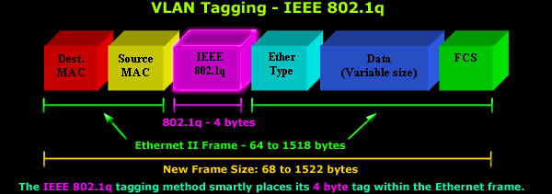
TPID –always 0x8100 for 802.1Q
CFI VID
PCP
TCI

16 bit 3-bit 1-bit 12-bit
TPID- defined value of 8100 in hex. When a frame has the Ether Type equal to 8100, this frame carries the tag IEEE 802.1Q / 802.1P.
PCP (Priority Code Point) or COS (Classes of Service) is user priority is in the range 0 to 7
TCI: Tag Control Information
CFI if 1 indicates the inter LAN compatibility with Token ring, FDDI etc.This is 0 for us.
VID is the 12 bit VLAN ID. Total4096 VLANs are possible.
Length/Ether Type- 2 bytes. This field indicates either the number of MAC-client data bytes that are contained in the data field of the frame, or the frame type ID if the frame is assembled using an optional format.
Data- Is a sequence of nbytes (48=< n =<1500) of any value. The total frame minimum is 64bytes.
Frame check sequence (FCS)- 4 bytes. This sequence contains a 32-bit cyclic redundancy check (CRC) value, which is created by the sending MAC and is recalculated by the receiving MAC to check for damaged frames.

Using VLANs to Maximize the CoS Benefit
Without an 802.1Q tagged VLAN environment, CoS can prioritize only the movement of outbound traffic through individual switches in your network. Using 802.1Q tagged VLANs provides the maximum advantage by allowing CoS to set priorities that are supported by downstream devices. This means that CoS can support improved performance for present traffic levels as well as future traffic growth while optimizing the use of existing resources and delaying the need for further investments in equipment and services. That is, CoS enables you to:
* Specify which traffic in the switch has higher or lower priority, regardless of current network bandwidth or the relative priority setting of the traffic when it is received on the switch.
* Change (upgrade or downgrade) the priority of outbound traffic.
* Override ‘‘illegal’’ packet priorities set by upstream devices or applications that use 802.1Q VLAN tagging with 802.1p priority tags.
* Avoid or delay the need to add higher-cost NICs (network interface cards) to implement prioritizing.

Priority Settings for Outbound Packets
You can configure a CoS priority of 0 through 7 for an outbound packet. When the packet is then sent to a port, the CoS priority determines which outbound queue the packet uses.
CoS Setting | Outbound Port  Queue | Operation
0 - 3 | normal priority | Packets in this queue leave the port after the high-priority queue is emptied.
4 - 7 | high priority | Packets in this queue leave the port first.
If a packet is not in an 802.1Q tagged VLAN environment, the above settings control only to which outbound queue the packet goes, and no 802.1p priority is added to the packet. However, if the packet is in an 802.1Q tagged VLAN environment, then the above setting is also added to the packet as an 802.1p priority that can be used by downstream devices and applications.

Recommended criteria for Prioritizing Outbound Packets on switch
You can configure CoS prioritization on the basis of five criteria ranked as follows:
1) Device Priority (destination or source IP address)
2) IP Type of Service (ToS) field
3) Protocol Priority (IP, IPX, ARP, DEC LAT, AppleTalk, SNA, and NetBeui)
4) VLAN Priority
5) Incoming 802.1p Priority (present in tagged VLAN environments)

If more than one criteria is present in a packet, the highest ranked of the criteria is used to prioritize the packet; all lower-ranked criteria are ignored. For example, if CoS assigns:
- High priority to VLAN packets
- Normal priority to IP packets
Since Protocol Priority (third in precedence, as shown above) has precedence over VLAN priority (fourth in precedence, as shown above), IP packets on the VLAN will be set to normal priority.

Guidelines for Configuring Switch CoS Priorities:
You can use CoS regardless of whether the switch is in a tagged VLAN environment.
Using CoS in a tagged VLAN environment controls both of the following:
* Outbound port queue: To which queue (high or normal) a packet will be sent
* Outbound 802.1p priority: Enters a new 802.1p priority setting in an outbound packet or retains the packet’s existing 802.1p setting. This enables the packet to carry an 802.1p priority to the next downstream device.
Using CoS without a tagged VLAN environment affects only the outbound port queue to which a packet is sent. (That is, it prioritizes traffic flow only within the switch.) However, without a tagged VLAN environment, an outbound packet cannot carry an 802.1p priority setting to a downstream device.
To configure CoS, use this procedure:
Determine the CoS policy you want to implement. This includes analyzing the types of traffic flowing through your network and identifying one or more traffic types to prioritize. If two or more of your policies apply to the same packet, then the switch applies only the policy having the highest precedence. The order of precedence for CoS a criterion is as follows:
- Device Priority - destination or source IP address (Note that destination has precedence over source.)
- IP Type of Service (ToS renamed as DS or DiffServ now)
- Protocol Priority
- VLAN Priority (requires at least one tagged VLAN)
- Incoming 802.1p Priority (requires at least one tagged VLAN)
If we want 802.1p priority settings to be included in outbound packets, ensure that tagged VLANs are configured on the appropriate links. Determine the actual Class of Service configuration changes you will need to make to establish a CoS policy for the switch.

In CoS technology, 802.1p Priority field (PCP) has been given least priority. But we only consider this criteria for entire switch CoS policy.

Or else we can use IP TOS field for prioritizing the packets in the switch, this reduces the effort of doing VLAN tagging and setting COS field.

Traffic Control
Traffic control is the name given to the sets of queuing systems and mechanisms by which packets are received and transmitted on a router. This includes deciding which (and whether) packets to accept at what rate on the input of an interface and determining which packets to transmit in what order at what rate on the output of an interface.
When properly employed, traffic control should lead to more predictable usage of network resources and less volatile contention for these resources. The network then meets the goals of the traffic control configuration. Bulk download traffic can be allocated a reasonable amount of bandwidth even as higher priority interactive traffic is simultaneously serviced. Even low priority data transfer such as mail can be allocated bandwidth without tremendously affecting the other classes of traffic.
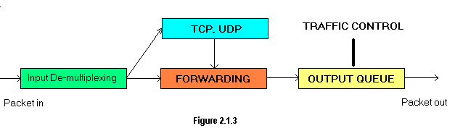

Traditional Elements of Traffic Control
Shaping: Shapers delay packets to meet a desired rate.
Scheduling: Schedulers arrange and/or rearrange packets for output.
Classifying: Classifiers sort or separate traffic into queues.
Policing: Policers measure and limit traffic in a particular queue.
Dropping: Dropping discards an entire packet, flow or classification.
Marking: Marking is a mechanism by which the packet is altered.

Components of Linux Traffic Control
Correlation between traffic control elements and Linux components
Traditional element Linux component
Shaping The class offers shaping capabilities.
Scheduling A qdisc is a scheduler. Schedulers can be simple such as the FIFO or complex, containing classes and other qdiscs, such as HTB.
Classifying The filter object performs the classification through the agency of a classifier object. Strictly speaking, Linux classifiers cannot exist outside of a filter.
Policing A policer exists in the Linux traffic control implementation only as part of a filter.
Dropping To drop traffic requires a filter with a policer which uses "drop" as an action.
Marking The DSMASK qdisc is used for marking.

qdisc:
A qdisc is a scheduler .Every output interface needs a scheduler of some kind, and the default scheduler is a FIFO. Other qdiscs available under Linux will rearrange the packets entering the scheduler's queue in accordance with that scheduler's rules.
The qdisc is the major building block on which all of Linux traffic control is built, and is also called a queuing discipline.
There are two types of queuing disciplines
  - classless :
FIFO, First-In First-Out (pfifo and bfifo)
pfifo_fast , the default Linux qdisc
SFQ, Stochastic Fair Queuing
ESFQ, Extended Stochastic Fair Queuing
RED, Random Early Detection
GRED, Generic Random Early Detection
TBF, Token Bucket Filter
  - classful :
HTB, Hierarchical Token Bucket
Diff-Serv Marker (DS_MARK)
PRIO, priority scheduler
CBQ, Class Based Queuing
Classful qdiscs are very useful if you have different kinds of traffic which should have differing treatment.

class
Classes only exist inside a classful qdisc ( e.g. , HTB and CBQ ). Classes are immensely flexible and can always contain either multiple children classes or a single child qdisc. There is no prohibition against a class containing a classful qdisc itself, which facilitates tremendously complex traffic control scenarios.
Any class can also have an arbitrary number of filter s attached to it, which allows the selection of a child class or the use of a filter to reclassify or drop traffic entering a particular class.
A leaf class is a terminal class in a qdisc. It contains a qdisc (default FIFO ) and will never contain a child class. Any class which contains a child class is an inner class (or root class) and not a leaf class.

filter
The filter is the most complex component in the Linux traffic control system. The filter provides a convenient mechanism for gluing together several of the key elements of traffic control. The simplest and most obvious role of the filter is to classify packets. Linux filters allow the user to classify packets into an output queue with either several different filters or a single filter.
A filter must contain a classifier phrase.
A filter may contain a policer phrase.
Filters can be attached either to classful qdisc s or to class es, however the enqueued packet always enters the root qdisc first. After the filter attached to the root qdisc has been traversed, the packet may be directed to any subclasses (which can have their own filters) where the packet may undergo further classification.

Here is a list of commonly used classifiers:
fw : Bases the decision on how the firewall has marked the packet. This can be the easy way out if you don't want to learn tc filter syntax.
u32:Bases the decision on fields within the packet (i.e. source IP address, etc)
route :Bases the decision on which route the packet will be routed by
rsvp, rsvp6 :Routes packets based on RSVP . Only useful on networks you control - the Internet does not respect RSVP.
tcindex :Used in the DSMARK qdisc, see the relevant section.
The u32 filter is the most advanced filter available in the current implementation. It entirely based on hashing tables, which make it robust when there are many filter rules.

classifier
Filter objects, which can be manipulated using tc , can use several different classifying mechanisms, the most common of which is the u32 classifier. The u32 classifier allows the user to select packets based on attributes of the packet.
The classifiers are tools which can be used as part of a filter to identify characteristics of a packet or a packet's metadata. The Linux classfier object is a direct analogue to the basic operation and elemental mechanism of traffic control classifying .
4.5. policer
This elemental mechanism is only used in Linux traffic control as part of a filter . A policer calls one action above and another action below the specified rate. Clever use of policers can simulate a three-color meter.
Although both policing and shaping are basic elements of traffic control for limiting bandwidth usage a policer will never delay traffic. It can only perform an action based on specified criteria. See also Example 5 .

drop
This basic traffic control mechanism is only used in Linux traffic control as part of a policer . Any policer attached to any filter could have a drop action.
Note : The only place in the Linux traffic control system where a packet can be explicitly dropped is a policer. A policer can limit packets enqueued at a specific rate, or it can be configured to drop all traffic matching a particular pattern
There are, however, places within the traffic control system where a packet may be dropped as a side effect. For example, a packet will be dropped if the scheduler employed uses this method to control flows as the GRED does.
Also, a shaper or scheduler which runs out of its allocated buffer space may have to drop a packet during a particularly bursty or overloaded period.

handle
Every class and classful qdisc (see also Section 7 ) requires a unique identifier within the traffic control structure. This unique identifier is known as a handle and has two constituent members, a major number and a minor number. These numbers can be assigned arbitrarily by the user in accordance with the following rules [3] .
The numbering of handles for classes and qdiscs
major
This parameter is completely free of meaning to the kernel. The user may use an arbitrary numbering scheme, however all objects in the traffic control structure with the same parent must share a major handle number. Conventional numbering schemes start at 1 for objects attached directly to the root qdisc.
minor
This parameter unambiguously identifies the object as a qdisc if minor is 0. Any other value identifies the object as a class. All classes sharing a parent must have unique minor numbers.
The special handle ffff:0 is reserved for the ingress qdisc.
The handle is used as the target in classid and flowid phrases of tc filter statements. These handles are external identifiers for the objects, usable by userland applications. The kernel maintains internal identifiers for each object.

Traffic control components in the kernel perspective

Queues
Queues form the backdrop for all of traffic control and are the integral concept behind scheduling. A queue is a location (or buffer) containing a finite number of items waiting for an action or service. In networking, a queue is the place where packets (our units) wait to be transmitted by the hardware (the service). In the simplest model, packets are transmitted in a first-come first-serve basis. In the discipline of computer networking (and more generally computer science), this sort of a queue is known as a FIFO.
Without any other mechanisms, a queue doesn't offer any promise for traffic control. There are only two interesting actions in a queue. Anything entering a queue is enqueued into the queue. To remove an item from a queue is to dequeue that item.
A queue becomes much more interesting when coupled with other mechanisms which can delay packets, rearrange, drop and prioritize packets in multiple queues. A queue can also use sub queues, which allow for complexity of behaviour in a scheduling operation.
From the perspective of the higher layer software, a packet is simply enqueued for transmission, and the manner and order in which the enqueued packets are transmitted is immaterial to the higher layer. So, to the higher layer, the entire traffic control system may appear as a single queue. It is only by examining the internals of this layer that the traffic control structures become exposed and available.

Flows
A flow is a distinct connection or conversation between two hosts. Any unique set of packets between two hosts can be regarded as a flow. Under TCP the concept of a connection with a source IP and port and destination IP and port represents a flow. A UDP flow can be similarly defined.
Traffic control mechanisms frequently separate traffic into classes of flows which can be aggregated and transmitted as aggregated flow. Alternate mechanisms may attempt to divide bandwidth equally based on the individual flows.
Flows become important when attempting to divide bandwidth equally among a set of competing flows, especially when some applications deliberately build a large number of flows.

Tokens and buckets
Two of the key underpinnings mechanisms are the interrelated concepts of tokens and buckets.
In order to control the rate of dequeuing, an implementation can count the number of packets or bytes dequeued as each item is dequeued, although this requires complex usage of timers and measurements to limit accurately. Instead of calculating the current usage and time, one method, used widely in traffic control, is to generate tokens at a desired rate, and only dequeue packets or bytes if a token is available.
Tokens are generated at rate, and a maximum of a bucket's worth of tokens may be collected. This allows bursty traffic to be handled, while smoothing and shaping the transmitted traffic.

Packets and frames
The terms for data sent across network changes depending on the layer the user is examining. This document will rather impolitely (and incorrectly) gloss over the technical distinction between packets and frames although they are outlined here.
The word frame is typically used to describe a layer 2 (data link) unit of data to be forwarded to the next recipient. Ethernet interfaces, PPP interfaces, and T1 interfaces all name their layer 2 data unit a frame. The frame is actually the unit on which traffic control is performed.
A packet, on the other hand, is a higher layer concept, representing layer 3 (network) units. The term packet is preferred in this documentation, although it is slightly inaccurate.

Common traffic control solutions
- Limit total bandwidth to a known rate; TBF, HTB with child class (es).
- Limit the bandwidth of a particular user, service or client; HTB classes and classifying with a filter.
- Maximize TCP throughput on an asymmetric link; prioritize transmission of ACK packets.
- Reserve bandwidth for a particular application or user; HTB with children classes and classifying.
- Prefer latency sensitive traffic; PRIO inside an HTB class.
- Managed oversubscribed bandwidth; HTB with borrowing.
- Allow equitable distribution of unreserved bandwidth; HTB with borrowing.
- Ensure that a particular type of traffic is dropped; policer attached to a filter with a drop action.

HTB is the most commonly used queuing discipline now in the Linux traffic Control, which suits for our applications. So our recommended qdisc is HTB.

HTB introduction
HTB is meant as a more understandable, intuitive and faster replacement for the CBQ qdisc in Linux. Both CBQ and HTB help you to control the use of the outbound bandwidth on a given link. Both allow you to use one physical link to simulate several slower links and to send different kinds of traffic on different simulated links. In both cases, you have to specify how to divide the physical link into simulated links and how to decide which simulated link to use for a given packet to be sent.
This document shows you how to use HTB. Most sections have examples, charts (with measured data) and discussion of particular problems.
Note: tc tool (not only HTB) uses shortcuts to denote units of rate. kbps means kilobytes and kbit means kilobits !
For a flat link-sharing structure such as in Figure 2.8.1, the link-sharing requirements are fairly straightforward. A link-sharing bandwidth is allocated to each class (expressed in Figure 2.8.1 as a percentage of the overall link bandwidth). These link-sharing allocations could be either static (permanently assigned by the network administrator) or dynamic (varying in response to current conditions on the network, according to some predetermined algorithm). The first link-sharing goal is that each class with sufficient demand should be able to receive roughly its allocated bandwidth, over some interval of time, in times of congestion.
As a consequence of this link-sharing goal, in times of congestion some classes might be restricted to their link-sharing bandwidth. For a class with a link-sharing allocation of zero, such as the mail class in Figure 2.8.1, the bandwidth received by this class is determined by the other scheduling mechanisms at the gateway; the link-sharing mechanisms do not “guarantee” any bandwidth to this class in times of congestion.
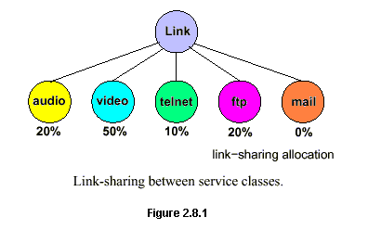
The second type is known as hierarchical link-sharing structure. Again, Floyd & Jacobson explain this as follows:
Multiple link-sharing constraints at a gateway can be expressed by a hierarchical link-sharing structure such as in Figure 2.8.2. The link-sharing structure in Figure 2.8.2 illustrates link-sharing between organizations, between protocol families, between service classes, and between individual connections within a service class; this is not meant to imply that all link-sharing structures at all links should include all of these forms of link-sharing. All arriving packets at the gateway are assigned to one of the leaf classes; the interior classes are used to designate guidelines about how `excess' bandwidth should be allocated. Thus, the goal is that the three service classes for agency A should collectively receive 50% of the link bandwidth over appropriate time intervals, given sufficient demand. If the real-time class for agency A has little data to send, the hierarchical link-sharing structure specifies that the `excess' bandwidth should be allocated to other subclasses of agency A.
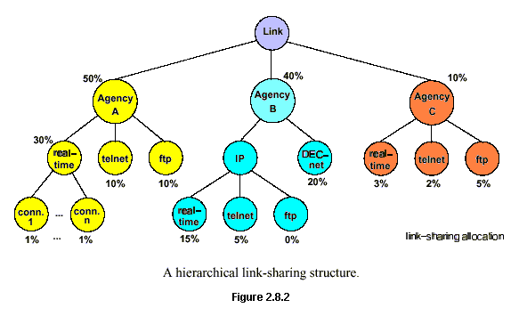
The link-sharing goals can be summarized as follows:
- Each interior or leaf class should receive roughly its allocated link-sharing bandwidth over appropriate time intervals, given sufficient demand.
- If all leaf and interior classes with sufficient demand have received at least their allocated link-sharing bandwidth, the distribution of any `excess' bandwidth should not be arbitrary, but should follow some set of reasonable guidelines.
Observe that this structure is more flexible than the flat one. In the flat approach you have only one level of bandwidth distribution. In the hierarchical approach you can have multiple levels of bandwidth distribution increasing the flexibility to distribute the available bandwidth between the classes to be served.
Have a look to the hierarchical structure. Observe that the classes could be organizations or agencies (first level in the figure); protocol families (second level in the B agency); traffic types, as is shown in the second level of A and C agencies and the third level of B agency; or connections as is shown in the bottom level of A agency.
To implement a hierarchical link-sharing structure you have to put a lot of resources in the game because the model consumes CPU cycles generously. With the current technology managing high-speed WAN links using hierarchical approach is yet non-practical. For example, Cisco doesn't have yet this type of queuing discipline implemented in its routers. In this case Linux is one step ahead from Cisco because two hierarchical queuing disciplines are already implemented: CBQ and HTB.
Let us suppose we want to implement a hierarchical link-sharing structure using HTB. HTB is so nice that it is not necessary to begin with a long explanation about parameters and all those complicated matters. We can go directly, on a fast-track explanation. Let's begin by drawing our network example scheme:
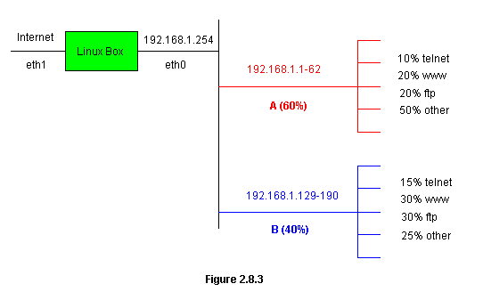
Two subnetworks, A and B, are going to be fed from a 2.048Mbps Internet connection through the 192.168.1.254 interface of our green Linux box depicted in the figure. A HTB queuing discipline will be installed on ethernet interface eth0 to control bandwidth distribution. Subnetwork A will have 60% of the available bandwidth guaranteed; subnetwork B the rest (40%). Within each subnetwork the guarantee flows for each type of service are as is indicated in the figure.
Next we draw our traditional queuing discipline diagram:
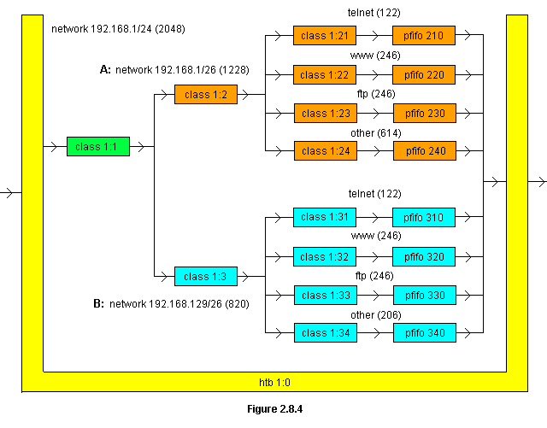

Yellow figure represents our HTB queuing discipline named 1:0. To permit borrowing between classes (more about this is explained below) HTB qdisc requires to create a root class depicted in the figure as a green rectangle; the root class is named 1:1. From this class we set two subclasses: class 1:2 will be used to control traffic to the network 192.168.1/26 and class 1:3 will be used to control traffic to the network 192.168.129/26. These classes represent the second level of hierarchy in our implementation. The third level is represented by the subclasses 1:21, 1:22, 1:23 and 1:24 belonging to the class 1:2 and the subclasses 1:31, 1:32, 1:33 and 1:34 belonging to the subclass 1:3. These subclasses will be used to distribute bandwidth at the service (third) level. For each of these subclasses a pfifo queuing discipline is configured for packet enqueuing. Final network, sub-networks and services bandwidth requirements are shown in parenthesis in kilobits per second (kbit).
Our next step will be to configure the HTB queuing discipline. We depict each command first and then a brief explanation is given to clear what we are doing.
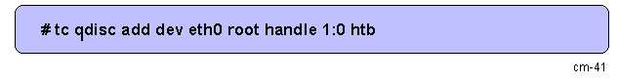
This command creates the root HTB queuing discipline on ethernet interface eth0. Nothing more is required for our example. The queuing discipline is called 1:0.
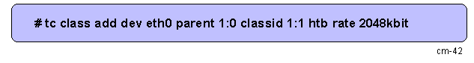
Next we create the root class 1:1. The rate parameter establishes the maximum bandwidth that will be permitted by the queuing discipline.
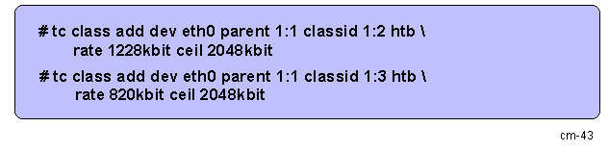
Now we create the class 1:2 to control flows to the A network (192.168.1/26) and the class 1:3 to control flows to the B network (192.168.129/26). The rate parameter is the minimum bandwidth that will be guaranteed to a class when all the classes in the queuing discipline are underprovisioned; this means, when flows reclaim rates that are equal or above the values set by the rate parameters. Let's explain this better. Being the A network flows equal or above 1228kbit and (simultaneously) the B network flows equal or above 820kbit, the minimum bandwidth to be guaranteed to classes 1:2 and 1:3 will be 1228kbit and 820kbit respectively.

HTB ensures that the amount of service provided to each class is at least the minimum of the amount it requests and the amount assigned to it. When a class requests less than the amount assigned, the remaining (excess) bandwidth is distributed to other classes which request service.
What about if a class is overprovisioned? Then the ceil parameter enters the game. For example, being the class 1:3 overprovisioned (consuming less than 820kbit), the class 1:2 can reclaim the excess left by the 1:3 class and uses this excess up to the value set by the ceil parameter, this means, up to 2048kbit. But, and this is very important, to allowing this borrowing (between classes 1:2 and 1:3), the HTB queuing discipline has to be configured including the root class 1:1.
But, what about if we don't want this borrowing? For example, let's suppose A and B network owners pay a fixed rate for their connections. They don't want that when he/she is not using his/her bandwidth another people uses it to take advantage of the share he/she pays. To avoid this problem we can re-write the last two commands using the value of the rate parameter as the ceil parameter; this way:
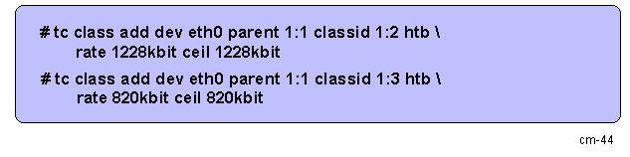
Our next step will be to configure the service classes on each network. Let's begin with network A:
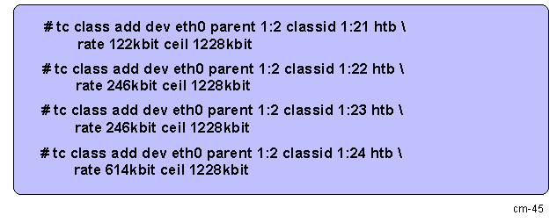
Observe here that we set the rates defined for each service but also we define a ceil parameter equal to the share permitted to the network A. This is another way to limit the maximum amount to be assigned to network A. Being the ceil parameter of classes 1:2 and 1:3 set to 2048kbit will be not matter because the top level will be controlled by the ceil parameter on service level subclasses.
The commands are very similar to configure the network B:
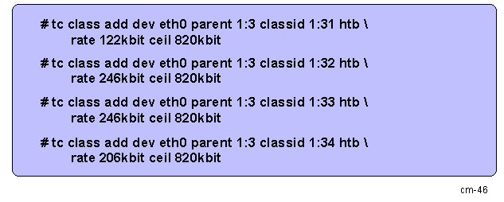
With these commands we have configured the part corresponding to the HTB queuing discipline. As you see HTB configuration is a very easy and friendly process. Having defined your class hierarchy you have to deal only with the rate and ceil parameters to get the job done. Really HTB has some other parameters to refine its behavior. But because this is the Differentiated Service HOWTO and not the HTB HOWTO,
To continue let's add a pfifo queuing discipline to each of the service classes; the commands are as follows:
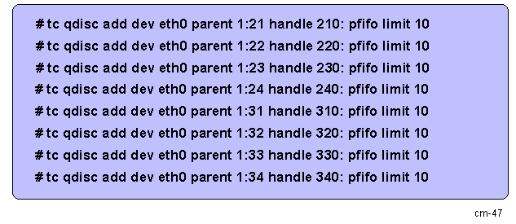
Well, fellows, we are almost ready. But, first, we have to configure the filter that places the packets on each class. Let's see how to do this beginning with network A:
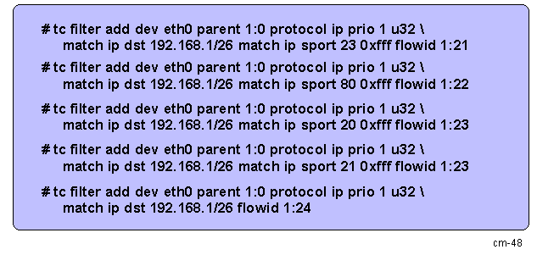
All these filter elements (the filter is just one, the prio1 filter) match to destination ip address range 192.168.1/26 corresponding to network A. The flowid parameter indicates the class where the packets matching the corresponding filter element will be placed. Source ports 23, 80, 20 and 21 correspond to service telnet, www, ftp and ftp-data respectively from the remote servers. Last filter element matches any packet belonging to the network 192.168.1/26 not being previously matched by upper elements (in fact, the rest of A network flows). Because 192.168.1/24 is a private address range some kind of NAT server has to be implemented on the Linux box in front to the Internet connection. But this is not a matter to this HOWTO.
Commands to configure B network filter elements are very similar:
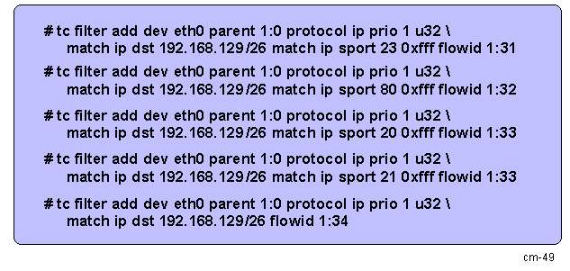

References
[1] | IEEE VLAN | http://standards.ieee.org/getieee802/download/802.1Q-1998.pdf
[2] | VLAN tagging | http://www.firewall.cx/vlans-tagging.php
[3] | Linux VLAN Configuration | http://www.cyberciti.biz/tips/howto-configure-linux-virtual-local-area-network-vlan.html
[4] | **COS configuration  Imp Link | http://www.hp.com/rnd/device_help/help/hpwnd/webhelp/HPJ4120A/configuration_cos.htm
[5] | Basic Definition | http://en.wikipedia.org/wiki/Time_to_live
[6] | Setting TTL value through socket options | UNIX Network programming vol-1:Richard Stevens
[7] | Windows socket options | http://msdn.microsoft.com/en-us/library/ms738586.aspx
[8] | Linux socket options | Linux man pages
[9] | MTU | http://en.wikipedia.org/wiki/Maximum_transmission_unit
[10] | Windows registry API | http://msdn.microsoft.com/en-us/library/ms724875.aspx
[11] | Internet MTU | http://www.psc.edu/~mathis/MTU/arguments.html.
[12] | Windows registry guide | http://support.microsoft.com/kb/256986
[13] | Linux traffic Control | http://tldp.org/HOWTO/Traffic-Control-HOWTO/software.html
[14] | HTB explained | http://www.opalsoft.net/qos/DS-28.htm
[15] | QoS and HTB | http://luxik.cdi.cz/~devik/qos/htb/
[16] | Taffic Control How To | http://www.bigwebmaster.com/General/Howtos/Traffic-Control-HOWTO/
[17] | DSMASK qdisc | http://www.opalsoft.net/qos/DS-29.htm
[18] | Hierarchical token bucket theory | http://luxik.cdi.cz/~devik/qos/htb/manual/theory.htm
[19] | filters | http://lartc.org/howto/lartc.adv-filter.html

Definitions and Abbreviations
COS | Classes of Service
VLAN | Virtual Local Area Network
TCI | Tag Control Information
MAC | Media Access Control
PCP | Priority Code Point (COS)
FCS | Frame Check Sequence
TTL | Time to Live
ICMP | Internet control message Protocol.
MTU | Maximum Transmission Unit
inbound port | Any port on a switch through which traffic enters the switch.
outbound port | Any port on a switch through which traffic leaves the switch.
RSVP | Resource Reservation Protocol

Task and Context
Tasks
- In order to set MTU values through application we have to find out the optimum values for different interfaces (Ethernet, Token ring,PPPoE etc) and have to find out the mechanisms to Get and Set MTU values:
- In order to make efficient network throughput we have to set TTL field of IP packets from the application
- In order to implement QoS at Layer 2, we have to set CoS (PCP) field of VLAN tag with the given value from the application.
Context
As a part of QoS Implementation in Layer2 and Layer3 for AVN/NMM systems we are investigating this.

Environment used and Software/Hardware Setup
We are using Open SuSe Linux 10.2/Windows installed on two different Hp machines, using HP NetXtreme BCM5752 Gigabit Ethernet PCI Express card (which supports VLAN tagging) and its driver is tg3 (which also supports VLAN tagging), for testing purpose.
Note: For CoS setting NIC card and its driver should support VLAN tagging and switch also has to support VLAN tagging and should be configured for VLAN tagging. Be sure that 8021q module should be installed. Check the existence of this module by using lsmod command.

Solution(s)
This section describes the solutions on how to set MTU, TTL and COS values.
We are assuming all applications will run in root mode.

MTU solutions

Setting MTU on Linux Machine
Through ioctl () call we can achieve this.
Create a TCP/UDP socket through which you want to send the packets.
struct ifreq ifr;//we can find this structure info in net/if.h
//This structure contains network interface details like interface name, MAC address etc.
Char iname [5] = “eth0”;
//creating socket
sd = socket (AF_INET, SOCK_STREAM, 0);

//Setting the interface name (assume “etho”)
//Binding socket to the given interface
setsockopt (sd, SOL_SOCKET, SO_BINDTODEVICE, iname, sizeof (iname));

/**************Code to be written**************
* -> filling struct sockaddr_in structure.
* -> Server code will contain bind () call here.
* -> Client code will contain connect () call here.
************************************************/
//clearing ifr structure.
memset(&ifr, 0, sizeof(ifr));

//Getting interface name from the socket
ioctl(sd,SIOCGIFNAME,&ifr);//gets the name of the interface

strcpy(iname,ifr.ifr_name);//stroring tempororily

//clearing ifr structure.
memset(&ifr, 0, sizeof(ifr));

strcpy(ifr.ifr_name,iname);//setting the interface name

ifr.ifr_mtu = mtu;//setting MTU for the same

//ioctl to set desired MTU for the network interface
ioctl(sd, SIOCSIFMTU, &ifr);

This call will set the MTU of the network interface which is being used by
Socket sd.

Complete code can be found in Appendix B.

Setting MTU on Windows Machine
We can set MTU values through registry editing, we found related API to set, get MTU values on windows.
HKLM\SYSTEM\CurrentControlSet\Services\Tcpip\Parameters\Interfaces\<interface-name> is the key to modify MTU.

#ifndef _REGISTRY_H
#define _REGISTRY_H
#include<windows.h>
#include<stdio.h>
#include<stdlib.h>
#include<winreg.h>

int getStringValue(char **lpVal, HKEY hkRoot, LPCTSTR lpszPath, LPTSTR lpszValue);
int getStringValues(char ***lpVal, HKEY hkRoot, const char *lpszPath, const char *lpszValue);
int setStringValue(CONST BYTE *lpVal, HKEY hkRoot, LPCTSTR lpszPath, LPCTSTR lpszValue);
int setStringValues(CONST BYTE **lpVal, HKEY hkRoot, LPCTSTR lpszPath, LPCTSTR lpszValue);
int makeNewKey(HKEY hkRoot, LPCTSTR lpszPath);
int deleteKey(HKEY hkRoot, LPCTSTR lpszPath);
#endif
These are the API methods to set MTU values.

TTL solutions
This section describes about two approaches to set TTL.
1) Through socket options: This is simple and efficient approach from the application side, and portable also. But if we want to control the network flow from a different application or if we want control more than one application from entirely different application, we have to create a gateway through which all desired packets will travel. This is possible through divert sockets.
2) Trough Divert sockets: Divert sockets divert kernel traffic to an application. After processing these captured (diverted) packets, application re-injects these packets again into the network.
As we are not fully aware of client’s requirements by this time, we had to investigate on this approach.

Setting TTL through socket options
Linux and windows both providing socket option system calls. So we can set TTL value through the same application.
Setsocketopt () system call sets various properties of the sockets.
Setting TTL Sample code:
Sfd= socket (AF_INET, SOCK_STREAM, 0);
ttl= 38; //some arbitrary value
Setsocketopt (sfd.IPPROTO_IP, IP_TTL, &ttl, sizeof (ttl));
All packets going through this socket will have TTL as 38.
We tested a sample TCP client-server application, and its working.

Setting TTL through divert sockets – packet filtering
If we want to set TTL value from a different application, we have to create an IP firewall or filter. We investigated on divert-socket mechanism. By using divert sockets we can intercept all out going packets from our application (or any application) which are just leaving IP layer and reaching Data-Link Layer. We stop all these packets and modify TTL field and release them into the actual flow.
Divert sockets:
As its name implies, it diverts the flow of the packets to the application where we have created divert socket. Based on the rules we have put for IP firewalling, packets will be captured here.

Application
IP firewall application, using divert sockets
After pre-routing process packets will be directed to the filter not to post routing process
TCP

IP pre routing
IP post routing

Data Link

Note:
But IP firewalling and divert sockets are obsolete in 2.6 kernels and only supported in 2.0 and 2.2 kernels and we need ipchains to configure the IP queues , which is obsolete. We made some programs and tried to run.In 2.6 Linux kernel Libraries are existing for IP firewalling and divert sockets. But kernel is not supporting at all. We tried to configure the kernel modules, but those options are not even present in the 2.6 kernel tree.
We are currently investigating on alternative mechanisms on Linux. iptables and netfilter will be the replacement for this.
We stopped investigation on this, as this approach will not reach clients expectations.

Setting COS (classes of service)
We found two ways to set COS.In both ways switch has to be 802.1Q enabled.
- By using ioctl() : This is easy but it needs 802.1Q setup in the machine
This needs 802.1Q enabled network card and corresponding driver and Kernel has to support 802.1Q.
To get full advantage of Layer 2 QOS we have to configure switch according to our needs.
On our test machine we are having this setup. We are assuming it will be supported in the client development machine.Here we are using VLAN tagging mechanism to add extra 4 byte tag to Ethernet frame. If we really want to maintain a Virtual LAN we can use this feature, or else we can simply create a dummy VLAN and dummy NIC.Here we are assuming we have a VLAN named vlan7 and network interface eth0.5 which internally uses eth0 interface.
- By using packet sockets: If we don’t want to have VLAN setup, then this is the only way we found.
For this instead of creating normal TCP socket we will create a packet socket through which we add VLAN tag. This is very raw approach. From getting MAC and IP addresses, to fill the packet headers everything we have to do manually, but this works very fast compared to normal application programs.

Setting CoS through Linux IOCTL
We can set CoS value by using ioctl () in Linux.
ioctl(sd, SIOCSIFVLAN, &if_request); - Sets the given values
ioctl(sd, SIOCGIFVLAN, &if_request); - Gets the current values.
In this structure if_request.vlan_qos = value; is the COS.
Where if_request is a struct vlan_ioctl_args type, which can be found in
/usr/include/linux/if_vlan.h at lines
381 struct vlan_ioctl_args {
382 int cmd; /* Should be one of the vlan_ioctl_cmds enum above. */
383 char device1 [24];
384
385 union {
386 char device2 [24];
387 int VID;
388 unsigned int skb_priority;
389 unsigned int name_type;
390 unsigned int bind_type;
391 unsigned int flag; /* Matches vlan_dev_info flags */
392 } u;
393
394 short vlan_qos; //This is the required COS field
395 };

Where cmd is one of the following enumerations

360 enum vlan_ioctl_cmds {
361 ADD_VLAN_CMD,
362 DEL_VLAN_CMD,
363 SET_VLAN_INGRESS_PRIORITY_CMD,
364 SET_VLAN_EGRESS_PRIORITY_CMD,
365 GET_VLAN_INGRESS_PRIORITY_CMD,
366 GET_VLAN_EGRESS_PRIORITY_CMD,
367 SET_VLAN_NAME_TYPE_CMD,
368 SET_VLAN_FLAG_CMD,
369 GET_VLAN_REALDEV_NAME_CMD, /* If this works, you know it's a VLAN device, btw */
370 GET_VLAN_VID_CMD /* Get the VID of this VLAN (specified by name) */
371 };

Pseudo code:

struct vlan_ioctl_args if_request;//linux/if_vlan.h
struct vlan_ioctl_args temp_ifr; //linux/if_vlan.h
struct if_req ifr;//net/if.h
Char iname [5] = “eth0.5”;//Assuming eth0.5 is the virtual NIC we have
//creating socket
sd = socket (AF_INET, SOCK_STREAM, 0);

//Setting the interface name (assume “eth0.5”)
//Binding socket to the given interface
setsockopt (sd, SOL_SOCKET, SO_BINDTODEVICE, iname, sizeof (iname));

/**************Code to be written **************
* -> filling struct sockaddr_in structure.
* -> Server code will contain bind () call here.
* -> Client code will contain connect () call here.
************************************************/
//clearing ifr structure.
memset(&ifr, 0, sizeof(ifr));

//Getting interface name from the socket
ioctl(sd,SIOCGIFNAME,&ifr);//gets the name of the interface

strcpy(iname,ifr.ifr_name);//stroring tempororily

//clearing ifr structure.
memset(&ifr, 0, sizeof(ifr));

if_request.u.name_type = DEV_PLUS_VID_NO_PAD;

if_request.device1 = “eth0.5”;//assume we have a virtual NIC # 5 on interface eth0
if_if_request.u.VID = 7;//assume we have vlan7

if_request.u.skb_priority = 0;//priority in socket buffer.

if_request.vlan_qos = vlan_qos; // this is CoS/ethernet QoS

ioctl(sd, SIOCSIFVLAN, &if_request);//sets the COS for the given interface
In the above code we are setting vlan_qos which is CoS.Here we are assuming we have a a virtual lan named ‘vlan7’ and virtual ethernet NIC ‘eth0.5’ which binds to ‘vlan7’.

Skb_priority is the priority of the packet in the socket buffer.

Once we set with thsese values.All out going packets will be prioritized by the given’ vlan_qos/Cos’ value.

We haven’t tested this,as we have to setup the vlan environment fro atleast three machines,and we need to have 802.1Q supported NICs and Switches.Due to less time we could not do the machine setup and testing.

Setting CoS by creating Linux PF_PACKET sockets

This is complicated way but without 802.1Q enabled NICs we can generate our own packets desired CoS values.

In this process we do not use TCP/IP stack,instead,we directly send the packets to NIC driver by including ethernet header.Etherenet driver does not add any header.If using TCP and IP isnecessary we can add these headers also.But we have to manually fill these headers and Manually divide the data to be sent according to the ethernet MTU.

Sample code for this.
Following structures will be used.
struct vlan_ethhdr vlan_hdr;
struct iphdr ip_hdr;
struct arphdr arp_hdr;
struct tcphdr tcp_hdr;

These structures are defined in header files in /usr/include/linux/ folder.
The following headers will be used for this program.

#include <stdio.h>
#include <string.h>
#include <sys/socket.h>
#include <netpacket/packet.h>
#include <net/ethernet.h>
#include <asm/types.h>
#include <linux/if_packet.h>
#include <linux/if_vlan.h>//this header is not usefule if do not have vlan enabled NIc.But still we can use this for vlan header struct vlan_ethhdr.
#include <sys/ioctl.h>
#include <linux/in.h>
#include <linux/if.h>
#include <linux/ip.h>
#include <linux/tcp.h>
#include <linux/udp.h>
#include <linux/icmp.h>
#include <stdlib.h>
Vlan header looks like this:

struct vlan_ethhdr {
unsigned char h_dest[ETH_ALEN]; /* destination eth addr */
unsigned char h_source[ETH_ALEN]; /* source ether addr */
unsigned short h_vlan_proto; /* Should always be 0x8100 */
unsigned short h_vlan_TCI; /* Encapsulates priority and VLAN ID */
unsigned short h_vlan_encapsulated_proto; /* packet type ID , use any unused prorocol number for this*/
};

Creating Packet socket

sd = socket(PF_PACKET, SOCK_RAW, htons(ETH_P_ALL))

Creating buffer to send the data.
#define ETHER_MTU 1496
char packet[ETHER_MTU+sizeof(struct vlan_ethhdr)]; //total packet including vlan header and data.

char *data;//this can be any size(say 4.8MB mp3 song)
we have to devide this into ETHER_MTU size blocks.

Steps to send data:
- Finding MAC address for the given destination machines IP .For this we have to use ARP prorocol.
- Filling vlan_ethhdr manually.In ether type filed of vlan_hdr use any unused network protocol number.
- Packing vlan_hdr and packet data into single data block.
- Writing through sendto () system call.

write (sd, packet,ETHER_MTU+sizeof(struct vlan_ethhdr));

For complete code refer Appendix D.

This is time consuming to develop test code for this, and we are not clear about the requirements. So we could not test it.

Rationale
[To be filled later]

Appendix

Appendix B: Setting MTU through socket options

#include <sys/socket.h>

#include <net/if.h>
#include <net/if_packet.h>
#include <netpacket/packet.h>

#include <net/ethernet.h>

int main()
{
struct ifreq ifr;
int s;
char *dev = "eth2";
int mtu;

printf("Enter MTU :");
scanf("%d",&mtu);

s = socket(AF_INET,SOCK_DGRAM,0);

if (s < 0)
printf("Error: Socket creation\n");

memset(&ifr, 0, sizeof(ifr));
strncpy(ifr.ifr_name, dev, sizeof(ifr.ifr_name));
ifr.ifr_mtu = mtu;
if (ioctl(s, SIOCSIFMTU, &ifr) < 0) {
printf("Error:SIOCSIFMTU\n");
close(s);
return -1;
}
close(s);
return 0;
}
This code is tested and working for the given environment.

Appendix B: vconfig.c – Application level program

/* This program will set VLAN tag with given values. */
/* This is a good example, to learn VLAN tag setting.*/
/* This simulates vconfig commandin Linux for VLANs. */
#include <errno.h>
#include <stdio.h>
#include <stdlib.h>
#include <unistd.h>
#include <fcntl.h>
#include <strings.h>
#include <sys/ioctl.h>
#include <linux/if_vlan.h>
#include <linux/sockios.h>
#include <string.h>
#include <sys/socket.h>
#include <sys/types.h>

#define MAX_HOSTNAME 256

static char* usage =
"\n"
"Usage: add [interface-name] [vlan_id]\n"
" rem [vlan-name]\n"
" set_flag [interface-name] [flag-num] [0 | 1]\n"
" set_egress_map [vlan-name] [skb_priority] [vlan_qos]\n"
" set_ingress_map [vlan-name] [skb_priority] [vlan_qos]\n"
" set_name_type [name-type]\n"
"\n"
"* The [interface-name] is the name of the ethernet card that hosts\n"
" the VLAN you are talking about.\n"
"* The vlan_id is the identifier (0-4095) of the VLAN you are operating on.\n"
"* skb_priority is the priority in the socket buffer (sk_buff).\n"
"* vlan_qos is the 3 bit priority in the VLAN header\n"
"* name-type: VLAN_PLUS_VID (vlan0005), VLAN_PLUS_VID_NO_PAD (vlan5),\n"
" DEV_PLUS_VID (eth0.0005), DEV_PLUS_VID_NO_PAD (eth0.5)\n"
"* bind-type: PER_DEVICE # Allows vlan 5 on eth0 and eth1 to be unique.\n"
" PER_KERNEL # Forces vlan 5 to be unique across all devices.\n"
"* FLAGS: 1 REORDER_HDR When this is set, the VLAN device will move the\n"
" ethernet header around to make it look exactly like a real\n"
" ethernet device. This may help programs such as DHCPd which\n"
" read the raw ethernet packet and make assumptions about the\n"
" location of bytes. If you don't need it, don't turn it on, because\n"
" there will be at least a small performance degradation. Default\n"
" is OFF.\n";

void show_usage() {
fprintf(stdout,usage);
}

int hex_to_bytes(char* bytes, int bytes_length, char* hex_str) {
int hlen;
int i;

int j = 0;
char hex[3];
char* stop; /* not used for any real purpose */

hlen = strlen(hex_str);

hex[2] = 0;

for (i = 0; i<hlen; i++) {

hex[0] = hex_str[i];
i++;
if (i >= hlen) {
return j; /* done */
}

hex[1] = hex_str[i];
bytes[j++] = (char)strtoul(hex, &stop, 16);
}
return j;
}

int main(int argc, char** argv) {
int fd;
struct vlan_ioctl_args if_request;

char* cmd = NULL;
char* if_name = NULL;
unsigned int vid = 0;
unsigned int skb_priority;
unsigned short vlan_qos;
unsigned int nm_type = VLAN_NAME_TYPE_PLUS_VID;

char* conf_file_name = "/proc/net/vlan/config";

memset(&if_request, 0, sizeof(struct vlan_ioctl_args));

if ((argc < 3) || (argc > 5)) {
fprintf(stdout,"Expecting argc to be 3-5, inclusive. Was: %d\n",argc);

show_usage();
exit(1);
}
else {
cmd = argv[1];

if (strcasecmp(cmd, "set_name_type") == 0) {
if (strcasecmp(argv[2], "VLAN_PLUS_VID") == 0) {
nm_type = VLAN_NAME_TYPE_PLUS_VID;
}
else if (strcasecmp(argv[2], "VLAN_PLUS_VID_NO_PAD") == 0) {
nm_type = VLAN_NAME_TYPE_PLUS_VID_NO_PAD;
}
else if (strcasecmp(argv[2], "DEV_PLUS_VID") == 0) {
nm_type = VLAN_NAME_TYPE_RAW_PLUS_VID;
}
else if (strcasecmp(argv[2], "DEV_PLUS_VID_NO_PAD") == 0) {
nm_type = VLAN_NAME_TYPE_RAW_PLUS_VID_NO_PAD;
}
else {
// MATHIEU
//cerr << "Invalid name type.\n";
fprintf(stderr,"Invalid name type.\n");

show_usage();
exit(1);
}
if_request.u.name_type = nm_type;
}
else {
if_name = argv[2];
if (strlen(if_name) > 15) {
// MATHIEU
//cerr << "ERROR: if_name must be 15 characters or less." << endl;
fprintf(stderr,"ERROR: if_name must be 15 characters or less.\n");
exit(1);
}
strcpy(if_request.device1, if_name);
}

if (argc == 4) {
vid = atoi(argv[3]);
if_request.u.VID = vid;
}

if (argc == 5) {
skb_priority = atoi(argv[3]);
vlan_qos = atoi(argv[4]);
if_request.u.skb_priority = skb_priority;
if_request.vlan_qos = vlan_qos;
}
}

// Open up the /proc/vlan/config
if ((fd = open(conf_file_name, O_RDONLY)) < 0) {
// MATHIEU
//cerr << "ERROR: Could not open /proc/vlan/config.\n";
fprintf(stderr,"WARNING: Could not open /proc/net/vlan/config. Maybe you need to load the 8021q module, or maybe you are not using PROCFS??\n");

}
else {
close(fd);
}

/* We use sockets now, instead of the file descriptor */
if ((fd = socket(AF_INET, SOCK_STREAM, 0)) < 0) {
fprintf(stderr, "FATAL: Couldn't open a socket..go figure!\n");
exit(2);
}

/* add */
if (strcasecmp(cmd, "add") == 0) {
if_request.cmd = ADD_VLAN_CMD;
if (ioctl(fd, SIOCSIFVLAN, &if_request) < 0) {
fprintf(stderr,"ERROR: trying to add VLAN #%u to IF -:%s:- error: %s\n",
vid, if_name, strerror(errno));
exit(3);
}
else {
fprintf(stdout,"Added VLAN with VID == %u to IF -:%s:-\n",
vid, if_name);
if (vid == 1) {
fprintf(stdout, "WARNING: VLAN 1 does not work with many switches,\nconsider another number if you have problems.\n");
}
}
}//if
else if (strcasecmp(cmd, "rem") == 0) {
if_request.cmd = DEL_VLAN_CMD;
if (ioctl(fd, SIOCSIFVLAN, &if_request) < 0) {
fprintf(stderr,"ERROR: trying to remove VLAN -:%s:- error: %s\n",
if_name, strerror(errno));
exit(4);
}
else {
fprintf(stdout,"Removed VLAN -:%s:-\n", if_name);
}
}//if
else if (strcasecmp(cmd, "set_egress_map") == 0) {
if_request.cmd = SET_VLAN_EGRESS_PRIORITY_CMD;
if (ioctl(fd, SIOCSIFVLAN, &if_request) < 0) {
fprintf(stderr,"ERROR: trying to set egress map on device -:%s:- error: %s\n",
if_name, strerror(errno));
exit(5);
}
else {
fprintf(stdout,"Set egress mapping on device -:%s:- "
"Should be visible in /proc/net/vlan/%s\n",
if_name, if_name);
}
}
else if (strcasecmp(cmd, "set_ingress_map") == 0) {
if_request.cmd = SET_VLAN_INGRESS_PRIORITY_CMD;
if (ioctl(fd, SIOCSIFVLAN, &if_request) < 0) {
fprintf(stderr,"ERROR: trying to set ingress map on device -:%s:- error: %s\n",
if_name, strerror(errno));
exit(6);
}
else {
fprintf(stdout,"Set ingress mapping on device -:%s:- "
"Should be visible in /proc/net/vlan/%s\n",
if_name, if_name);
}
}
else if (strcasecmp(cmd, "set_flag") == 0) {
if_request.cmd = SET_VLAN_FLAG_CMD;
if (ioctl(fd, SIOCSIFVLAN, &if_request) < 0) {
fprintf(stderr,"ERROR: trying to set flag on device -:%s:- error: %s\n",
if_name, strerror(errno));
exit(7);
}
else {
fprintf(stdout,"Set flag on device -:%s:- "
"Should be visible in /proc/net/vlan/%s\n",
if_name, if_name);
}
}
else if (strcasecmp(cmd, "set_name_type") == 0) {
if_request.cmd = SET_VLAN_NAME_TYPE_CMD;
if (ioctl(fd, SIOCSIFVLAN, &if_request) < 0) {
fprintf(stderr,"ERROR: trying to set name type for VLAN subsystem, error: %s\n",
strerror(errno));
exit(8);
}
else {
fprintf(stdout,"Set name-type for VLAN subsystem."
" Should be visible in /proc/net/vlan/config\n");
}
}
else {
fprintf(stderr, "Unknown command -:%s:-\n", cmd);

show_usage();
exit(5);
}

return 0;
}/* main */

Appendix C: Divert socket code
Divert socket code tested on Linux 2.6(Open SuSe 10.2):
#include <stdio.h>
#include <errno.h>
#include <limits.h>
#include <string.h>
#include <stdlib.h>
#include <unistd.h>
#include <getopt.h>
#include <netdb.h>
#include <netinet/in.h>
#include <sys/types.h>
#include <signal.h>

#include <netinet/ip.h>
#include <netinet/tcp.h>
#include <netinet/udp.h>
#include <net/if.h>
#include <sys/param.h>

#include <linux/types.h>
#include <linux/icmp.h>
#include <linux/ip_fw.h>

#define IPPROTO_DIVERT 254
#define BUFSIZE 65535

char *progname;

#ifdef FIREWALL

char *fw_policy="DIVERT";
char *fw_chain="output";

struct ip_fw fw;
struct ip_fwuser ipfu;
struct ip_fwchange ipfc;
int fw_sock;

/* remove the firewall rule when exit */
void intHandler (int signo) {

if (setsockopt(fw_sock, IPPROTO_IP, IP_FW_DELETE, &ipfc, sizeof(ipfc))==-1) {
fprintf(stderr, "%s: could not remove rule: %s\n", progname, strerror(errno));
exit(2);
}

close(fw_sock);
exit(0);
}

#endif

int main(int argc, char** argv)
{

int fd, rawfd, fdfw, ret, n;
int on=1;

int ttl_val=334;

struct sockaddr_in bindPort, sin;
int sinlen;
struct iphdr *hdr;
struct tcphdr *thdr;//added
unsigned char packet[BUFSIZE];
struct in_addr addr;
int i, direction;
struct ip_mreq mreq;

if (argc!=2) {
fprintf(stderr, "Usage: %s <port number>\n", argv[0]);
exit(1);
}
progname=argv[0];
fprintf(stderr,"%s:Creating a socket\n",argv[0]);
/* open a divert socket */
fd=socket(AF_INET, SOCK_RAW, IPPROTO_DIVERT);

if (fd==-1) {
fprintf(stderr,"%s:We could not open a divert socket\n",argv[0]);
exit(1);
}

bindPort.sin_family=AF_INET;
bindPort.sin_port=htons(atol(argv[1]));
bindPort.sin_addr.s_addr=0;

fprintf(stderr,"%s:Binding a socket\n",argv[0]);
ret=bind(fd, &bindPort, sizeof(struct sockaddr_in));

if (ret!=0) {
close(fd);
fprintf(stderr, "%s: Error bind(): %s",argv[0],strerror(ret));
exit(2);
}
#ifdef FIREWALL
/* fill in the rule first */
bzero(&fw, sizeof (struct ip_fw));
fw.fw_proto=2; /* ICMP */
fw.fw_redirpt=htons(bindPort.sin_port);
fw.fw_spts[1]=0xffff;
fw.fw_dpts[1]=0xffff;
fw.fw_outputsize=0xffff;

/* fill in the fwuser structure */
ipfu.ipfw=fw;
memcpy(ipfu.label, fw_policy, strlen(fw_policy));

/* fill in the fwchange structure */
ipfc.fwc_rule=ipfu;
memcpy(ipfc.fwc_label, fw_chain, strlen(fw_chain));

/* open a socket */
if ((fw_sock=socket(AF_INET, SOCK_RAW, IPPROTO_RAW))==-1) {
fprintf(stderr, "%s: could not create a raw socket: %s\n", argv[0], strerror(errno));
exit(2);
}

/* write a rule into it */
if (setsockopt(fw_sock, IPPROTO_IP, IP_FW_APPEND, &ipfc, sizeof(ipfc))==-1) {
fprintf(stderr, "%s could not set rule: %s\n", argv[0], strerror(errno));
exit(2);
}

/* install signal handler to delete the rule */
signal(SIGINT, intHandler);
#endif /* FIREWALL */

printf("%s: Waiting for data...\n",argv[0]);
/* read data in */
sinlen=sizeof(struct sockaddr_in);
while(1) {
n=recvfrom(fd, packet, BUFSIZE, 0, &sin, &sinlen);
/*********************************************************/
hdr=(struct iphdr*)packet;
thdr = (struct tcphdr*)(packet + hdr->tot_len * 4);

if(thdr->source == 8080)
{
hdr->ttl = ttl_val;
}
/**********************************************************/
printf("\n%s: The packet looks like this:\n",argv[0]);
for( i=0; i; i++) {
printf("%02x ", (int)*(packet+i));
if (!((i+1)%16)) printf("\n");
};
printf("\n");

addr.s_addr=hdr->saddr;
printf("%s: Source address: %s\n",argv[0], inet_ntoa(addr));
addr.s_addr=hdr->daddr;
printf("%s: Destination address: %s\n", argv[0], inet_ntoa(addr));
printf("%s: Receiving IF address: %s\n", argv[0], inet_ntoa(sin.sin_addr));
printf("%s: Protocol number: %i\n", argv[0], hdr->protocol);

/* reinjection */

#ifdef MULTICAST
if (IN_MULTICAST((ntohl(hdr->daddr)))) {
printf("%s: Multicast address!\n", argv[0]);
addr.s_addr = hdr->saddr;
errno = 0;
if (sin.sin_addr.s_addr == 0)
printf("%s: set_interface returns %i with errno =%i\n", argv[0], setsockopt(fd, IPPROTO_IP, IP_MULTICAST_IF, &addr, sizeof(addr)), errno);
}
#endif

#ifdef REINJECT
printf("%s Reinjecting DIVERT %i bytes\n", argv[0], n);
n=sendto(fd, packet, n ,0, &sin, sinlen);
printf("%s: %i bytes reinjected.\n", argv[0], n);

if (n<=0)
printf("%s: Oops: errno = %i\n", argv[0], errno);
if (errno == EBADRQC)
printf("errno == EBADRQC\n");
if (errno == ENETUNREACH)
printf("errno == ENETUNREACH\n");
#endif
}
}

Appendix D: packet sockets code

#include<stdio.h>
#include<stdlib.h>
#include<sys/socket.h>
#include<features.h>
#include<linux/if_packet.h>
#include<linux/if_ether.h>
#include<linux/if_vlan.h>
#include<errno.h>
#include<sys/ioctl.h>
#include<net/if.h>

#define PACKET_LENGTH 1046
/*
struct vlan_ethhdr {
unsigned char h_dest[ETH_ALEN]; /* destination eth addr */
unsigned char h_source[ETH_ALEN]; /* source ether addr */
unsigned short h_vlan_proto; /* Should always be 0x8100 */
unsigned short h_vlan_TCI; /* Encapsulates priority and VLAN ID */
unsigned short h_vlan_encapsulated_proto; /* packet type ID , use any unused prorocol number for this,we can use this field for packet sequencing*/
};
*/

int CreateRawSocket(int protocol_to_sniff)
{
int rawsock;

if((rawsock = socket(PF_PACKET, SOCK_RAW, htons(protocol_to_sniff)))== -1)
{
perror("Error creating raw socket: ");
exit(-1);
}

return rawsock;
}

int BindRawSocketToInterface(char *device, int rawsock, int protocol)
{

struct sockaddr_ll sll;
struct ifreq ifr;

bzero(&sll, sizeof(sll));
bzero(&ifr, sizeof(ifr));

/* First Get the Interface Index */

strncpy((char *)ifr.ifr_name, device, IFNAMSIZ);
if((ioctl(rawsock, SIOCGIFINDEX, &ifr)) == -1)
{
printf("Error getting Interface index !\n");
exit(-1);
}

/* Bind our raw socket to this interface */

sll.sll_family = AF_PACKET;
sll.sll_ifindex = ifr.ifr_ifindex;
sll.sll_protocol = htons(protocol);

if((bind(rawsock, (struct sockaddr *)&sll, sizeof(sll)))== -1)
{
perror("Error binding raw socket to interface\n");
exit(-1);
}

return 1;

}

int SendRawPacket(int rawsock, unsigned char *pkt, int pkt_len)
{
int sent= 0;

/* A simple write on the socket ..thats all it takes ! */

if((sent = write(rawsock, pkt, pkt_len)) != pkt_len)
{
return 0;
}

return 1;

}

/* argv[1] is the device e.g. eth0*/

int main(int argc, char **argv)
{

int raw;
unsigned char packet[PACKET_LENGTH + sizeof(struct vlan_ethhdr)];
int num_of_pkts;
struct vlan_ethhdr vlan_hdr;
char *buf;//this contains actual file to be transfered.
int fd;
unsigned short COS,VID;

/* Create the raw socket */

raw = CreateRawSocket(ETH_P_ALL);

/* Bind raw socket to interface */

BindRawSocketToInterface(argv[1], raw, ETH_P_ALL);

/**********This part has to be modified according the user needs***********/
fd= open(“abc.mp3”,O_RDONLY);

vlan_hdr.h_dest = ”destination MAC address”;
vlan_hdr.h_source = “Own MAC address”;
vlan_hdr.h_vlan_proto = 0x8100;//for 802.1q identification
vlan_hdr.h_vlan_TCI = ((COS & 0x0007) << 12) | (VID & 0x0FFF);

//here COS and VID has to be defined.

while(read(fd,&packet+sizeof(struct vlan_ethhdr),sizeof(PACKET_LENGTH)))
{
//adding vlan header
memcpy(&packet, &vlan_hdr,sizeof(vlan_hdr))
/*************************************************************************/
if(!SendRawPacket(raw, packet, PACKET_LENGTH))
{
perror("Error sending packet");
}
else
{
printf("Packet sent successfully\n");
}
}

close(raw);

return 0;
}

